Part 1

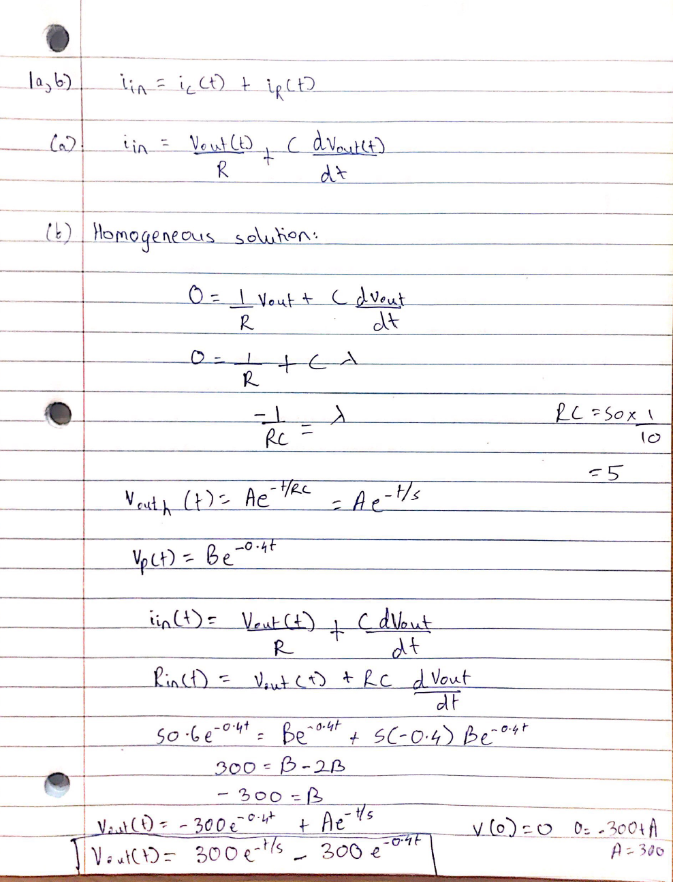Ans1 a,b)

Answer 2a)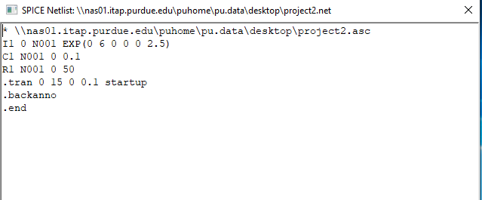

Ans 2b)

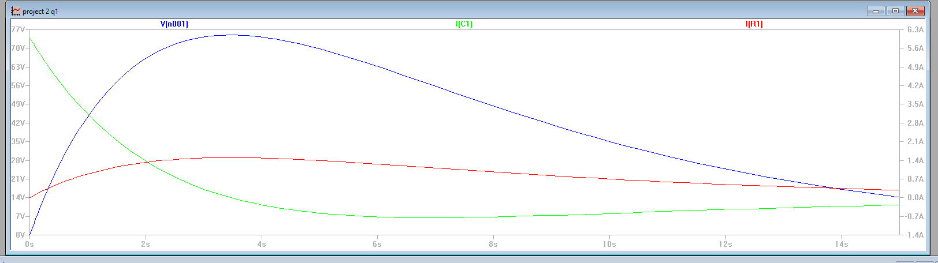

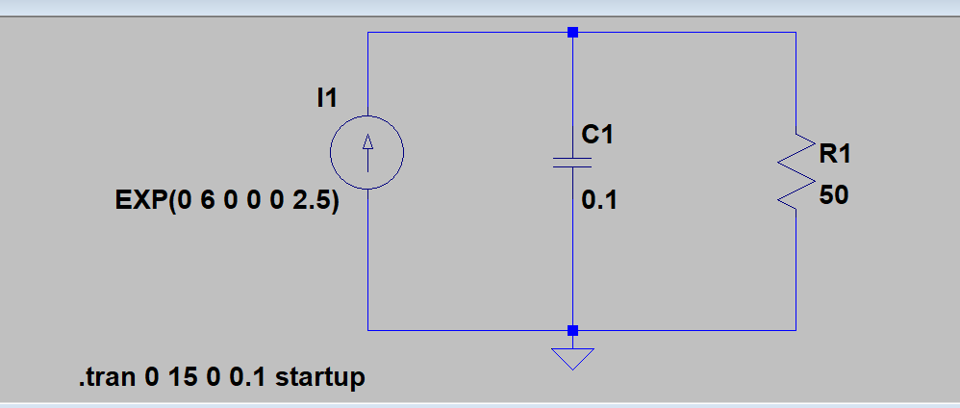

Part 2

Ans1) 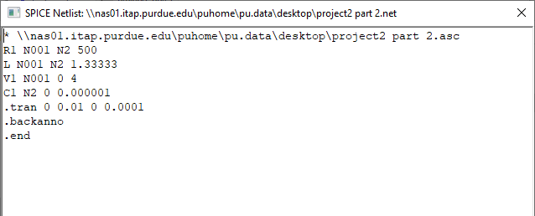

Ans2) A start time of t = 0 was used to commence data storage from rest. The time constant is = L/R = 1.333/500 = 0.002666. Taking three times the time constant yields 7.998 ms. Hence, we round up the stop time to 10ms. To ensure data collection over small intervals, the time step is adjusted to a level faster than the time constant. Therefore, a time step of 0.0001s is selected.

Ans3) 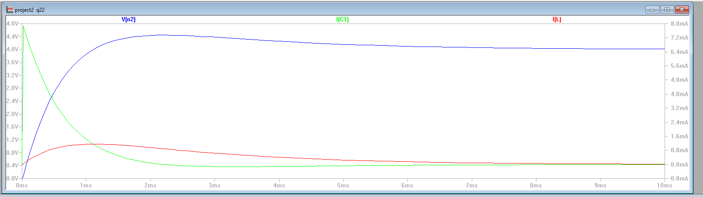

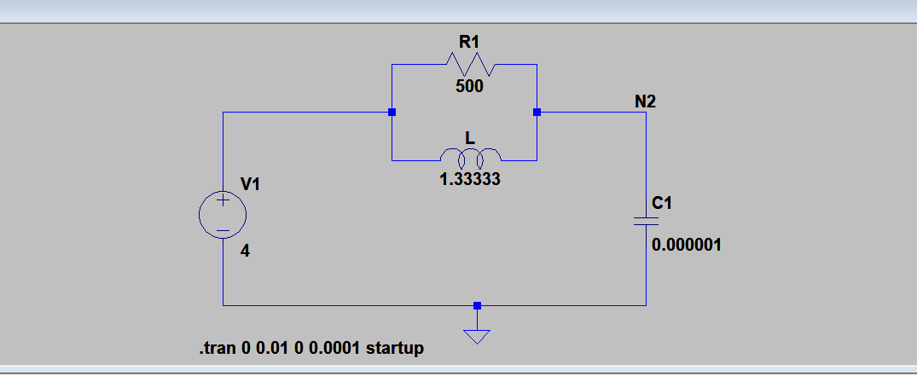

Ans4) Considering the steady state for an input of 4u(-t). An inductor behaves like a short circuit whereas a capacitor acts as an open circuit. Hence, IL(0+) = 0 A and Vc(0+) = 4 V.

Ans5) The justification stated in Part 2 Ans1 holds true for this circuit as well.

Ans6)

